**3.Group Member: Rownita Tasneem**

Progress & Achievements:

Our team member, Rownita Tasneem has changed the webpages according to the instructions of our respectable course instructor .In addition, she has created ‘About’ page , 4 new order pages, food-search and categories pages.

Here are the screen shots of the pages -

1. Top part of homepage

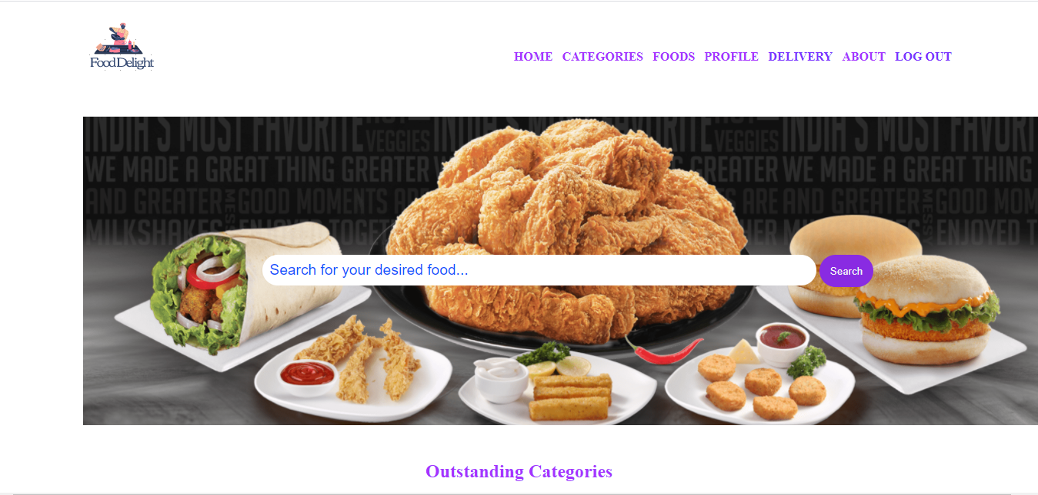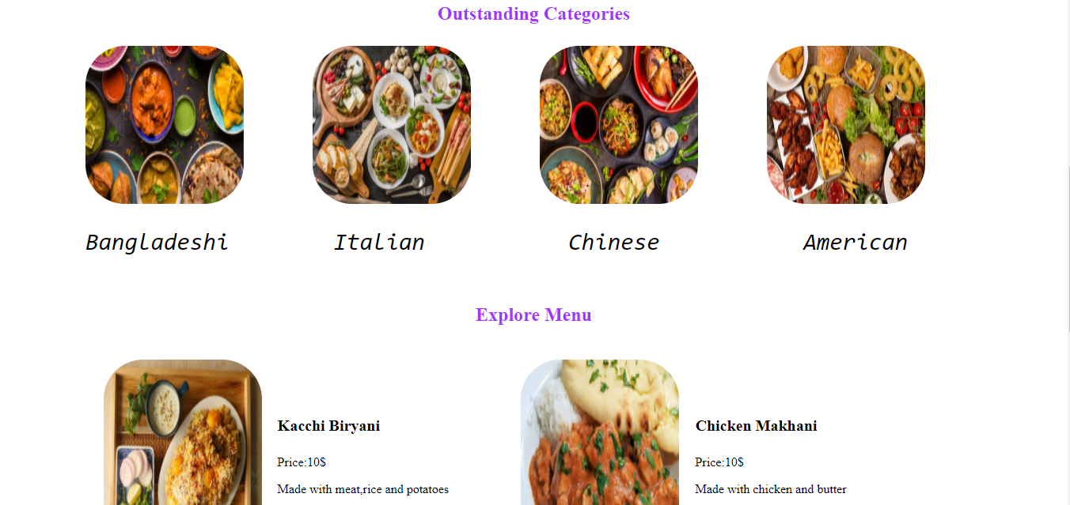

1. Middle Part of home page

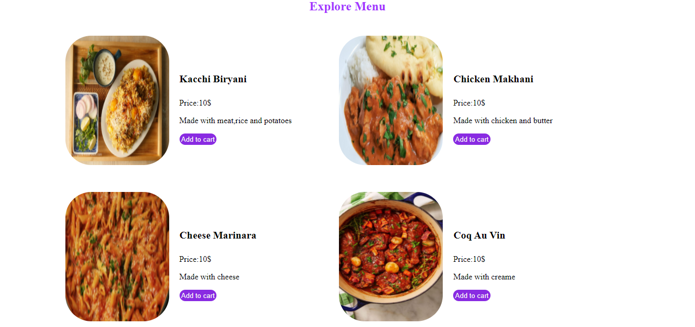

III.Bottom part of home page

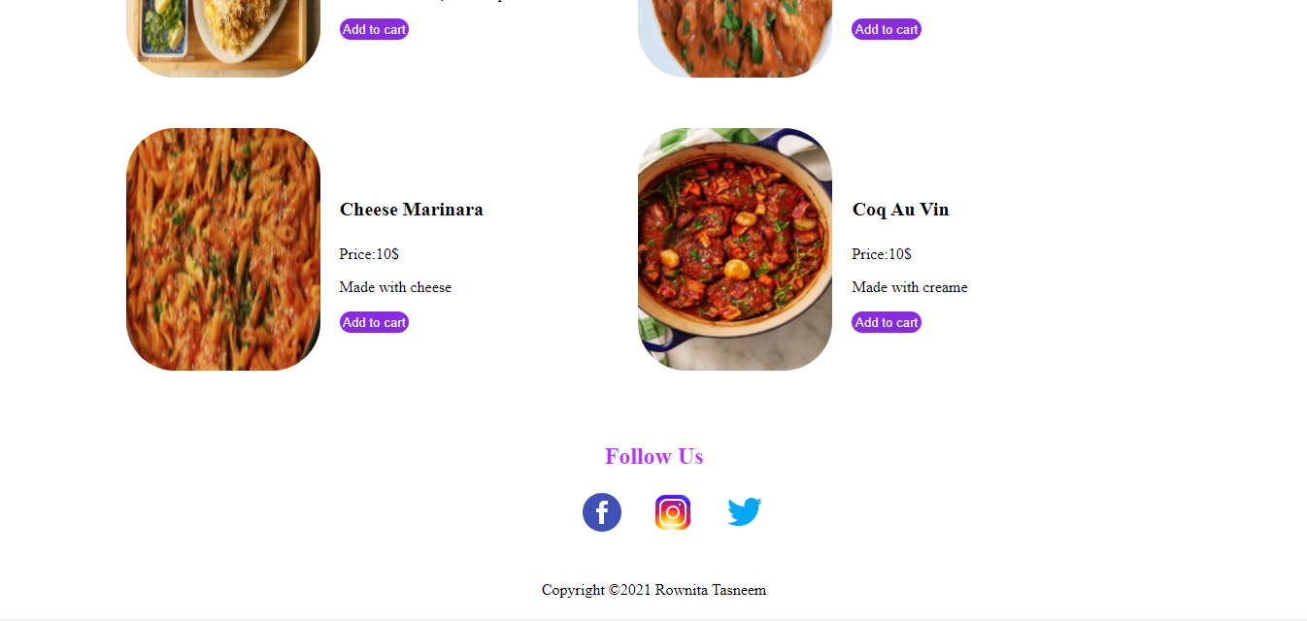

1. Top part of food-search page

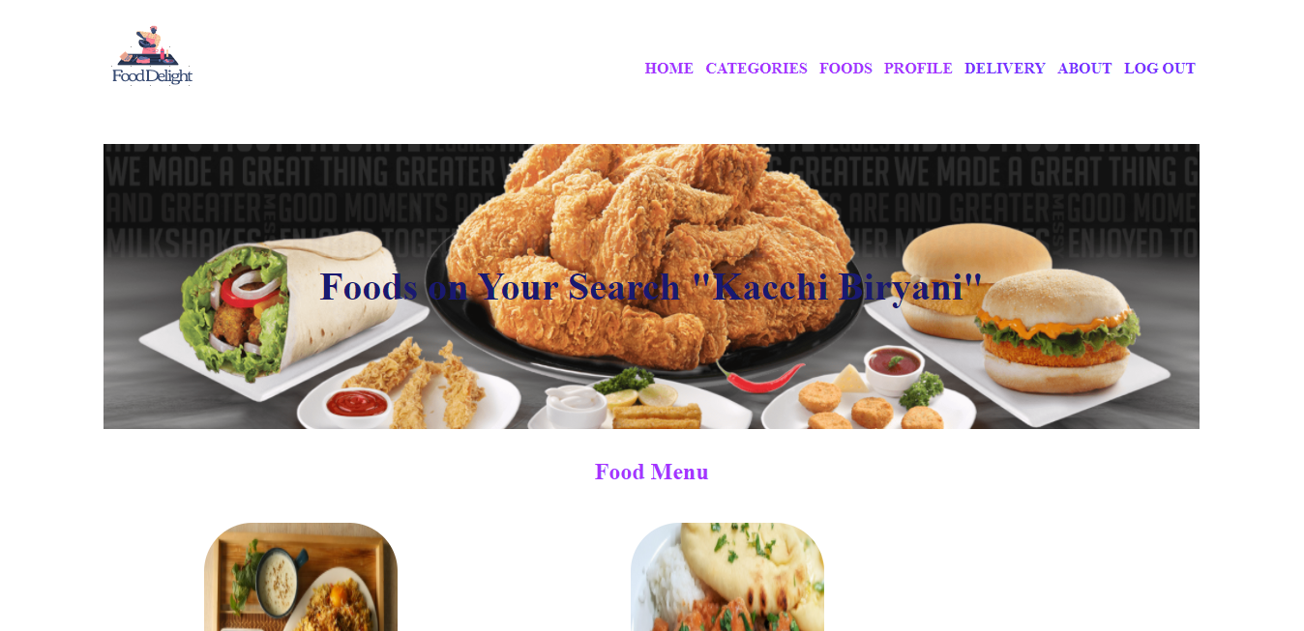

IV.Middle part of food-search page

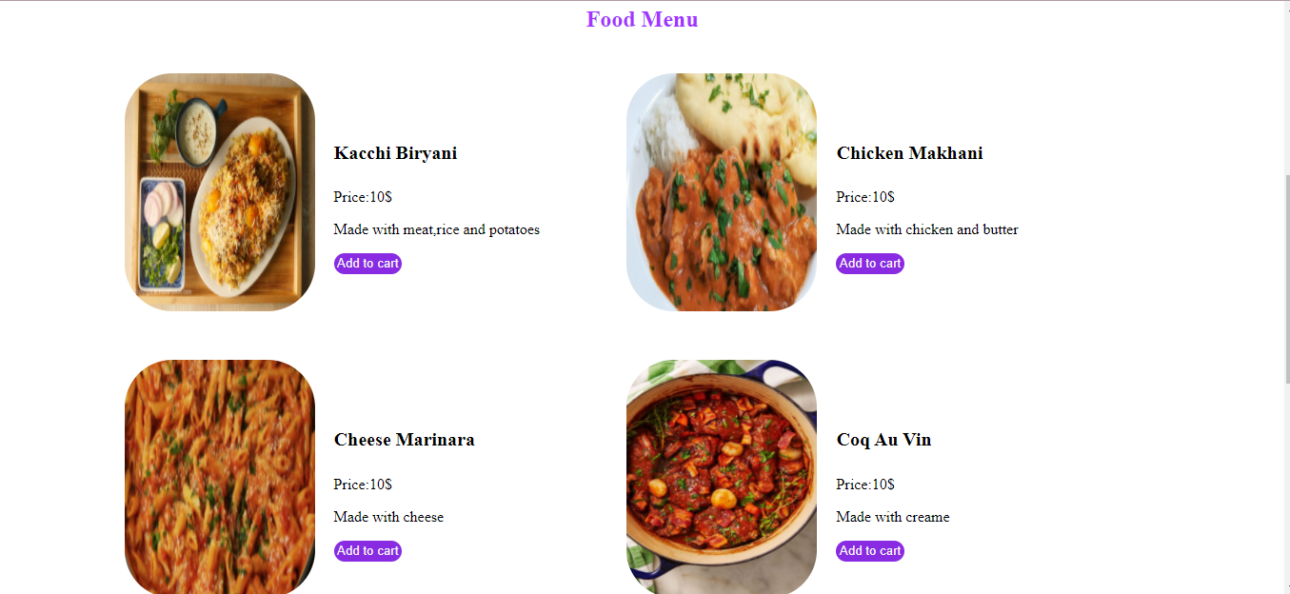

v.Last part of food-search page

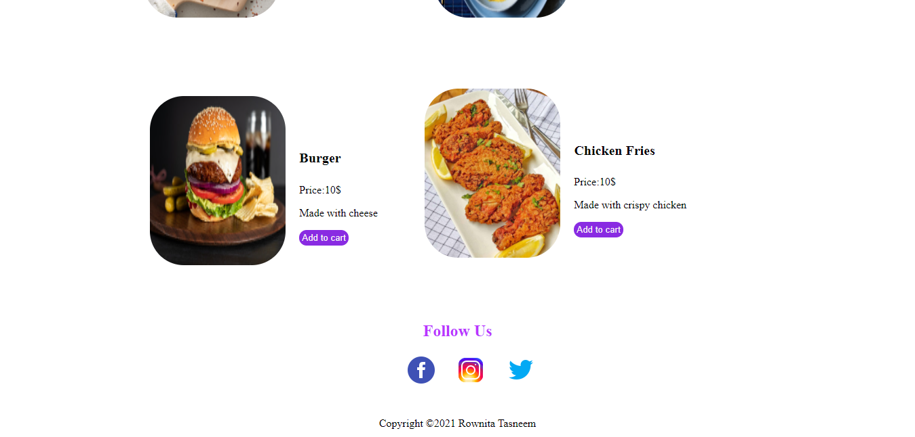

VI.Top part of Category –search page

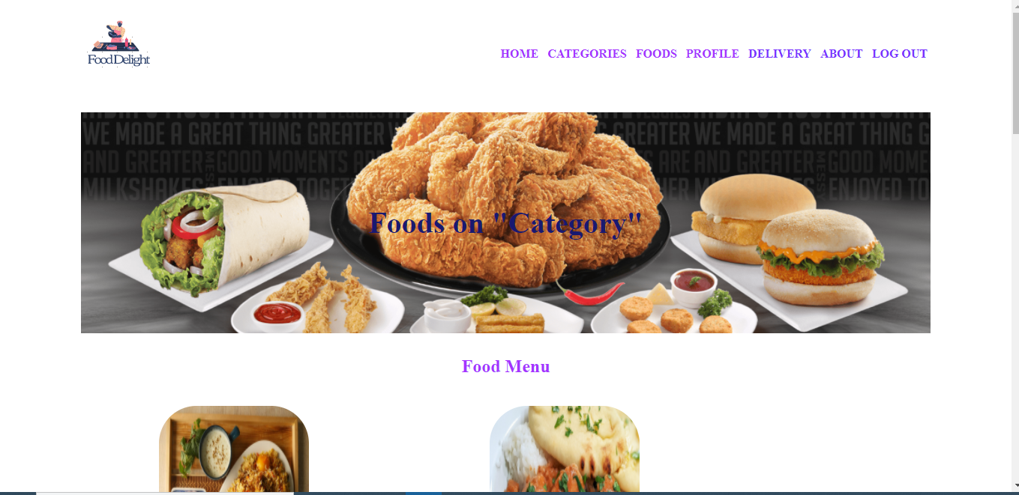

VII. Middle part of Category-search page

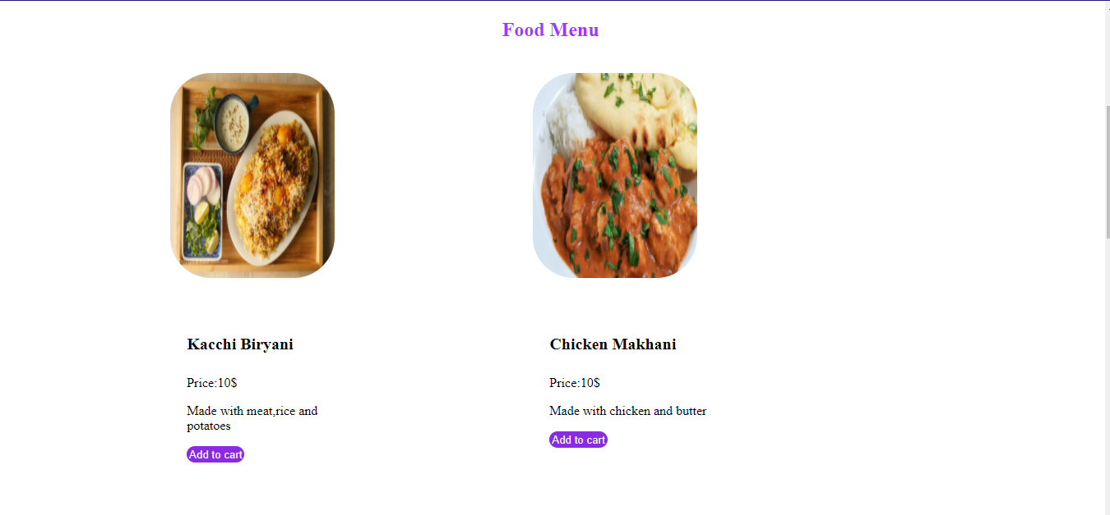

VIII. Second last part of category –search page

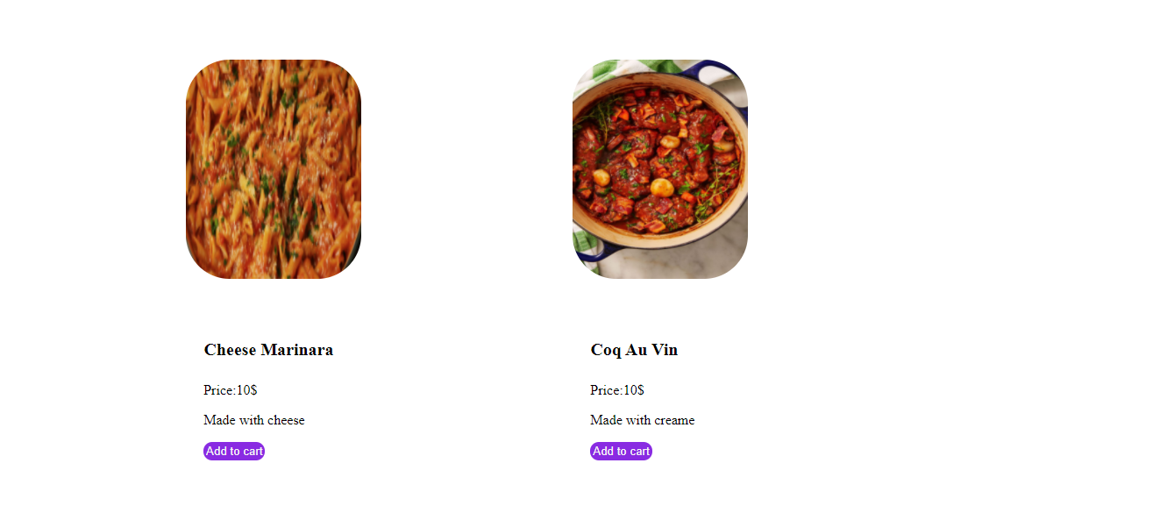

IX. Last part of category-search page

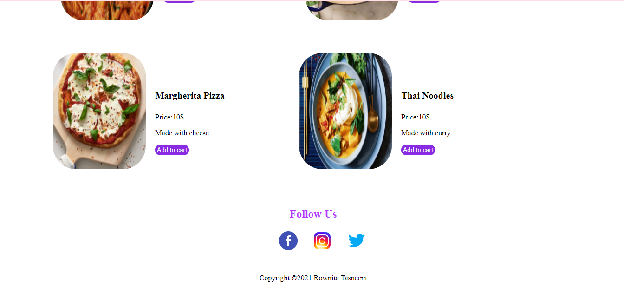

X.Top part of ‘About’ page

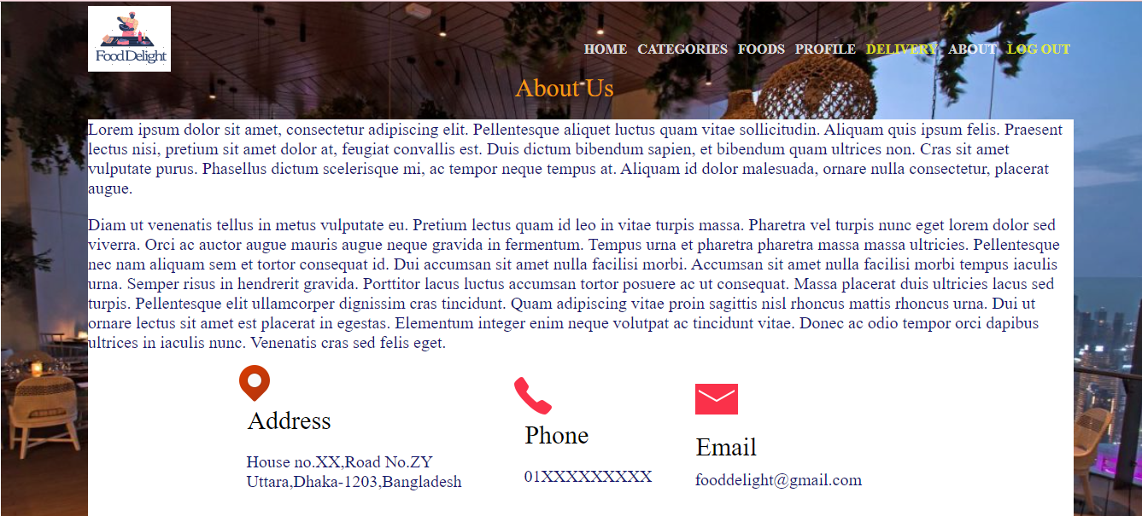

XI.Last part of ‘About’ page

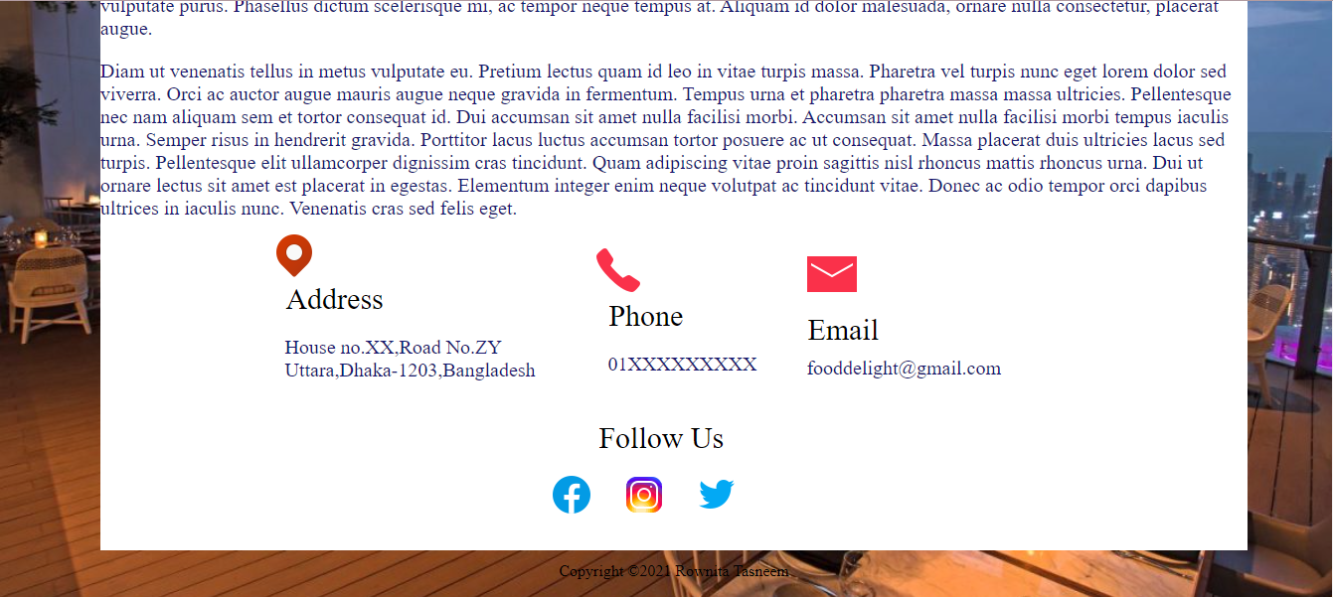

XII.Top part of user profile page

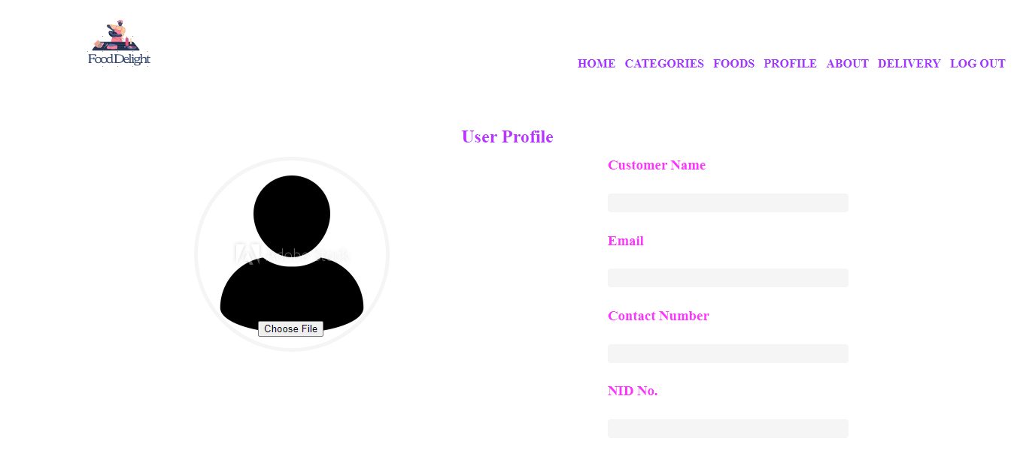

XIII. Last part of user profile page

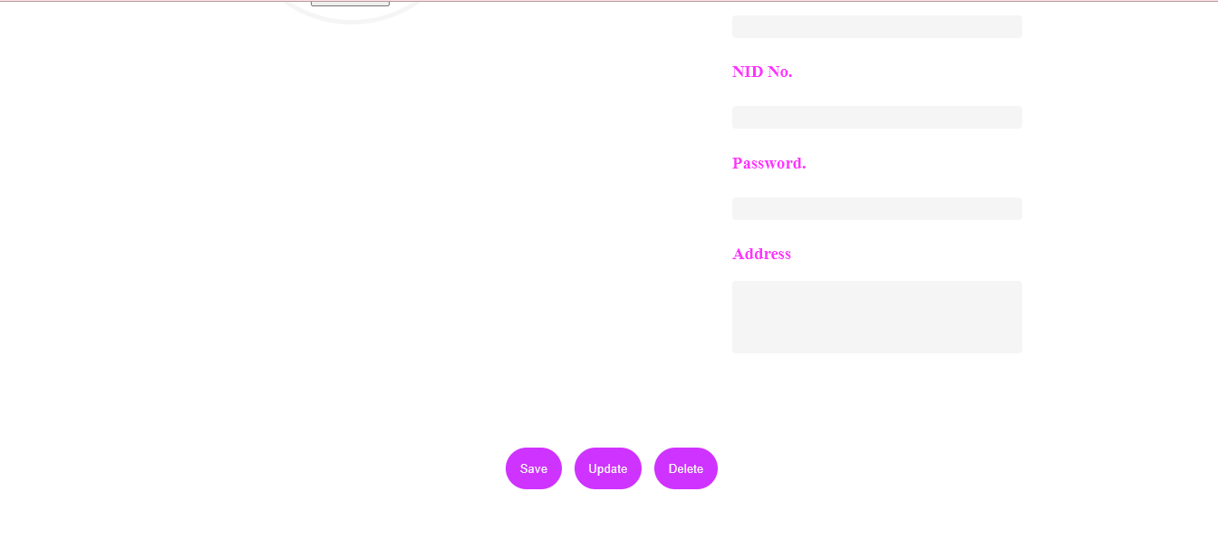

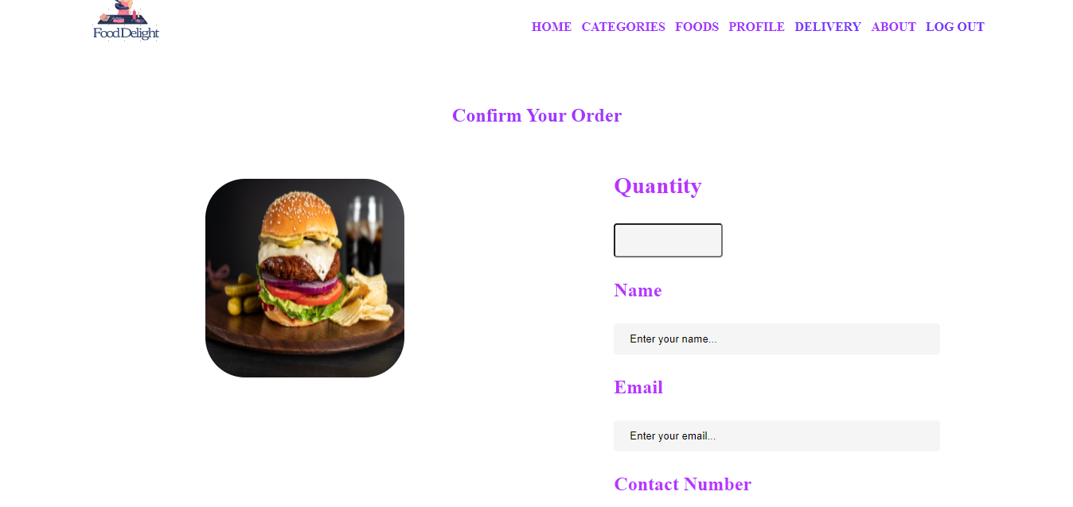

XIV. Top part of pizza order page

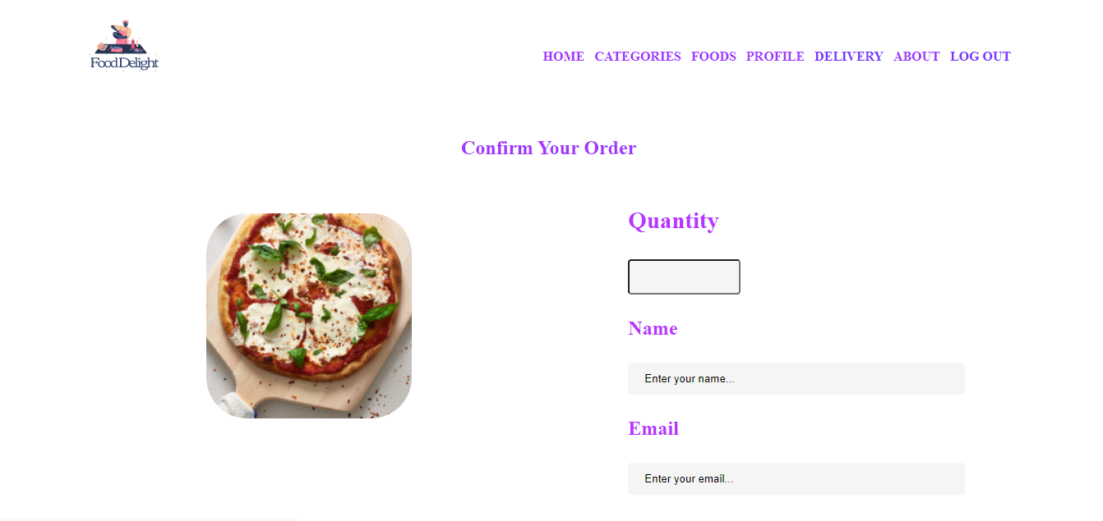

XV.Top part of chicken fry order page

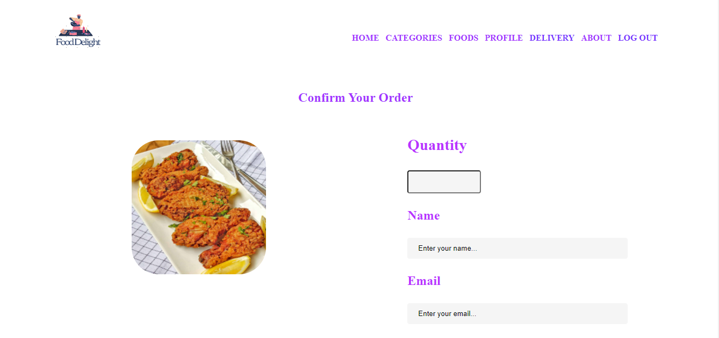

XVI.Top part of Thai noodles order page

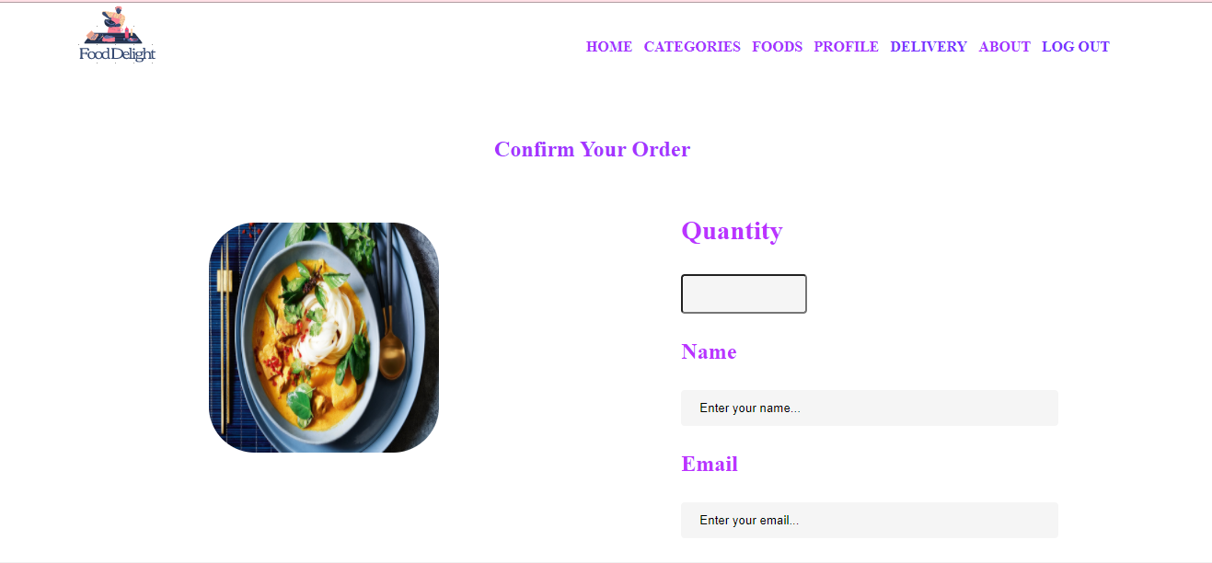

XVII.Top part of Biryani order page

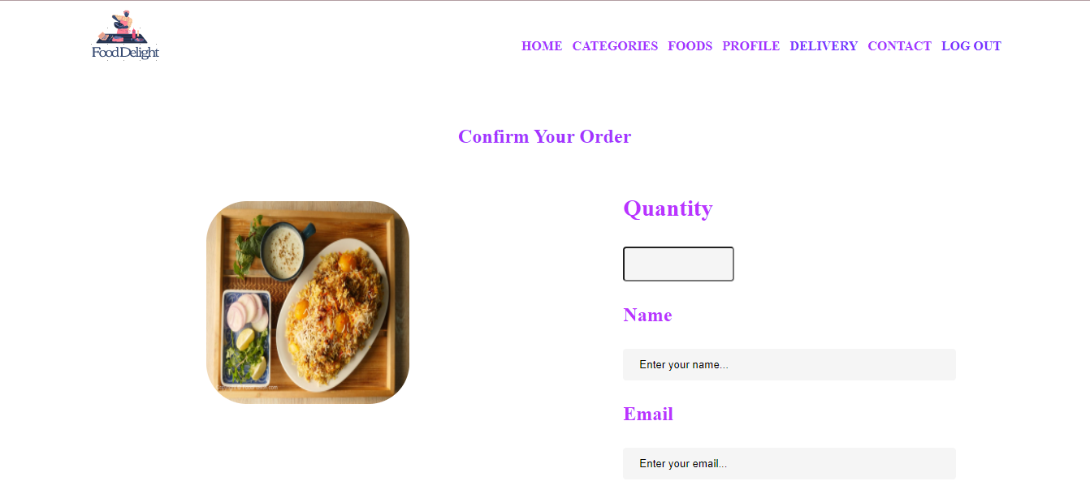

XVIII.Top part of Chicken Makhani order page

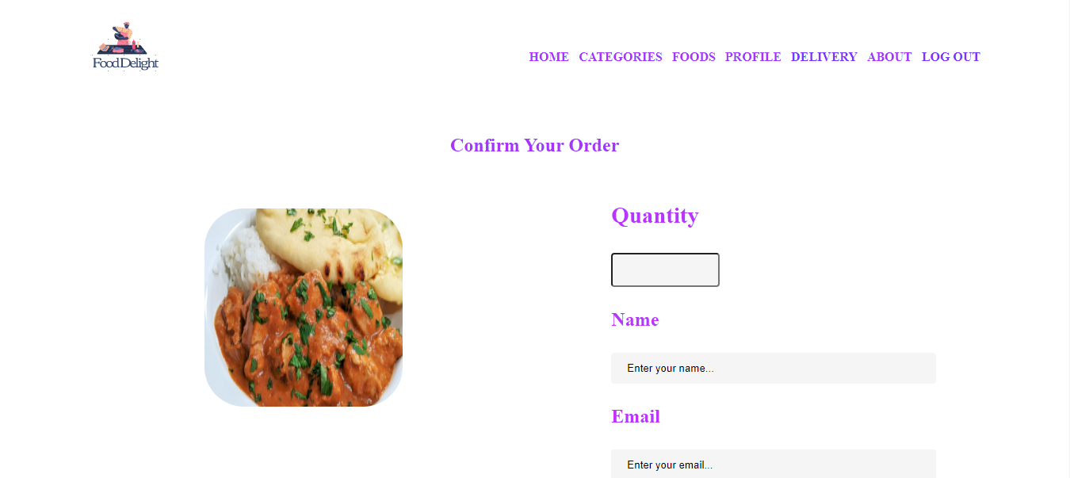

XXI.Top part Cheese Marinara order page

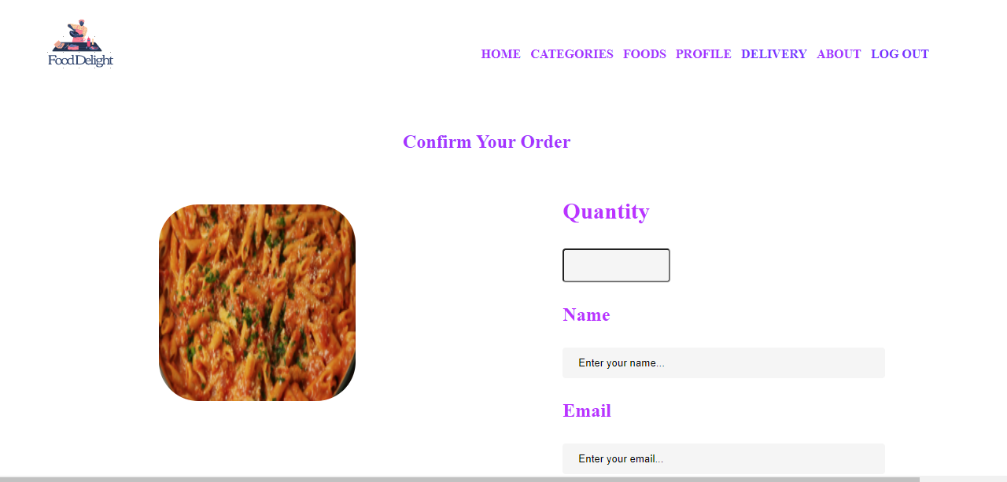

XX.Top part of Coq Au Vin order page

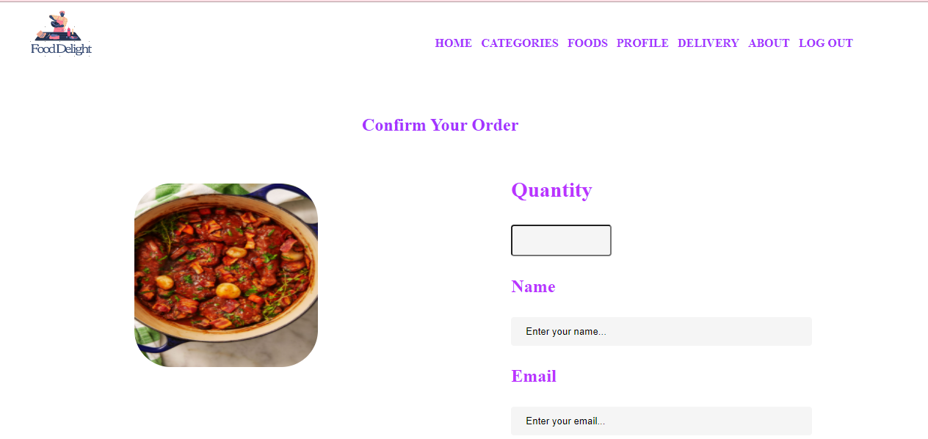

XXI.Last part of all the order pages

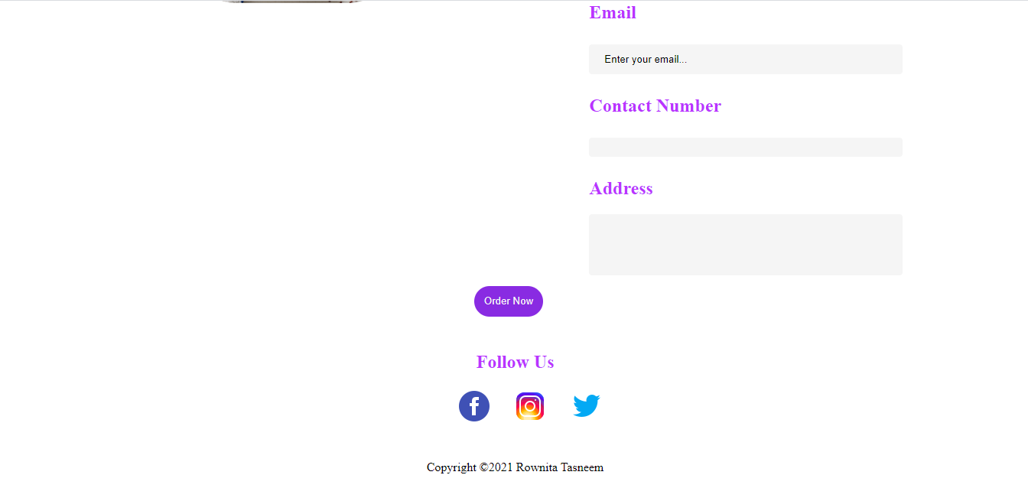

XXII.Top part of Foods page

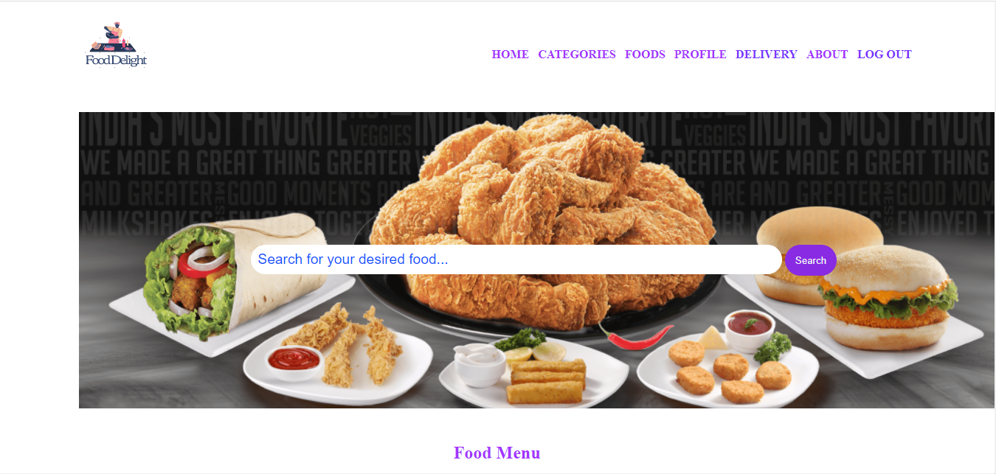

XXIII. Middle part of Foods page

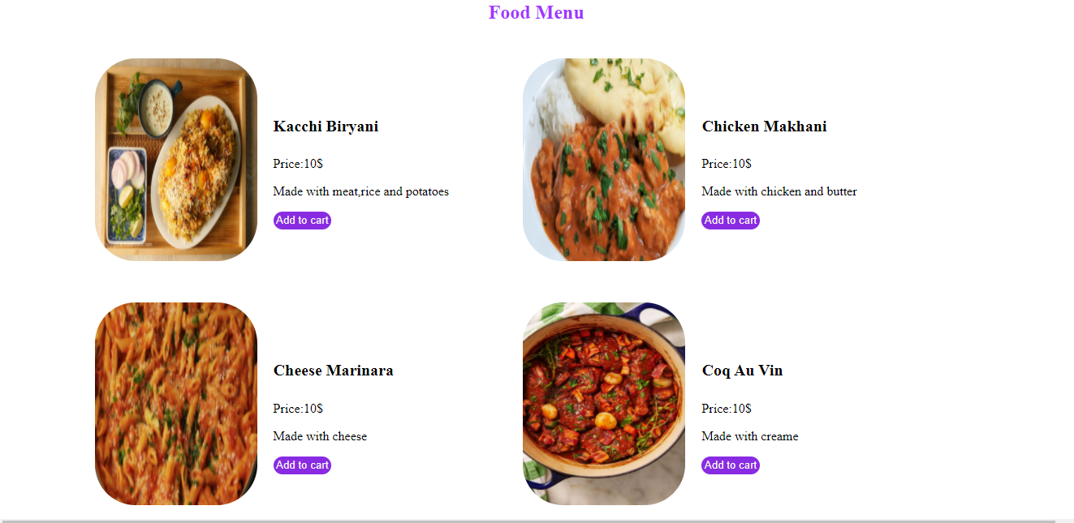

XXIV. Second last part of Foods page

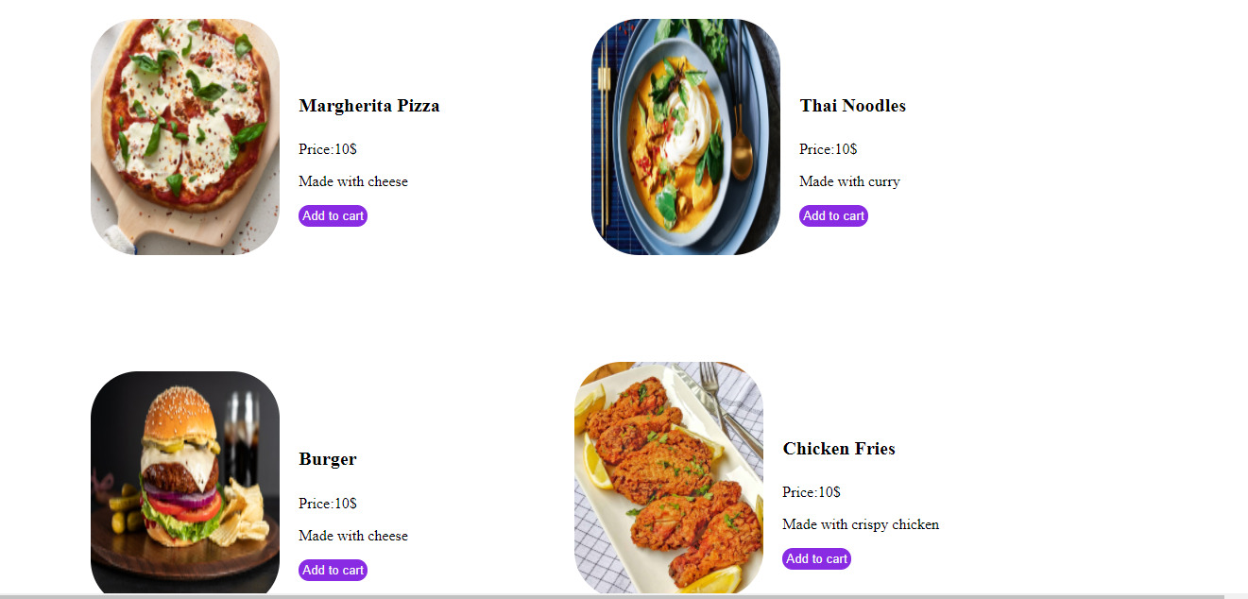

XXV.Last page of Foods page

